**General appearance of the login page**

1. Background
2. Font
3. Presence of elements: Login and Password fields, Login button, “Forgot your password” link, “Login with QR code” link, “English (Language)” link

**Login/Password fields**

*Positive test-cases:*

1. Entering a correct login and password
2. Hiding a password with asterisk signs and pressing the “eye” sign to unhide the entered password
3. Copy-paste to enter a login [Note: usually it is allowed, if not - so it is a negative test case]
4. **Note:** In order to test properly “...2” sign on the right of both Login and Password fields the requirements are needed, because it is not clear what function it is performing. It looks like it could be a virtual keyboard label, and in this case the test case will be here to test a correct work of a virtual keyboard.

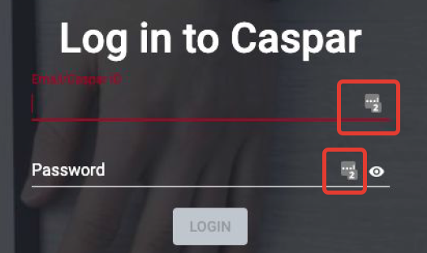

*Negative test-cases:*

1. Entering a not correct login and a correct password
2. Entering a correct login and a not correct password
3. Entering a not correct login and a not correct password
4. Entering a correct password using a different keyboard case
5. Leaving a login field empty
6. Leaving a password field empty
7. Leaving both login and password fields empty
8. Entering too many symbols to a login field
9. Entering too many symbols to a password field
10. Too many attempts to login
11. Copy-paste to enter a password [Note: more often it is not allowed, if it is allowed it should be a positive test case]

**Login button**

1. Login button can be easily pressed
2. Pressing “Enter” on the keyboard instead Login button [Note: this test-case can be used when the requirements allow this]

**“Forgot your password” link**

1. “Forgot your password” link re-addresses to the page using which User can change their credentials

**“Login with QR code” link**

*Positive:*

1. Correct QR code can be scanned and User logs in

*Negative*:

1. Wrong QR-code doesn’t allow User to log in
2. Any picture instead QR-code doesn’t allow User to log in
3. No QR-code doesn’t allow User to log in
4. Too many attempts to login with wrong QR code

**“English” link**

1. Switching the language of the page with “English” link (Note: the page is in English and still shows “English” link - logically it should show another language and it may be a bug then)